Lab Manual

**Object oriented programming**

**23CSE101**



Department of computer science of Engineering

Amrita School of Computing

Amrita Vishwa Vidyapeetham,

Amaravathi campus

Name: G.J.N.S.Chaitanya

Roll no:AV.SC.U4CSE24115

WEEK-1

Aim: To download and install JAVA Compiler on our laptops.

Procedure:

**Step1:** Search “JDK download” using a search engine

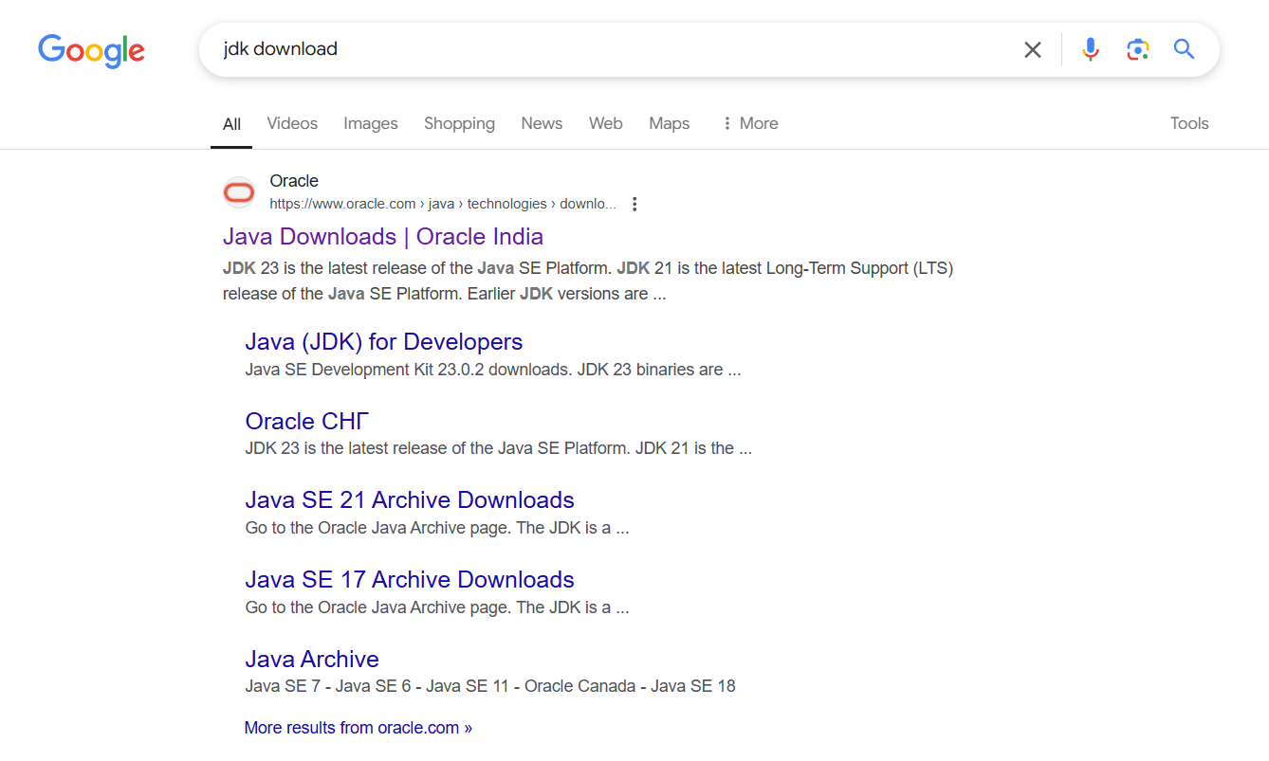

Step2: Click on the ORACEL website to download java

Step3: Select the 21.0.6 version which is suitable and stable for your system

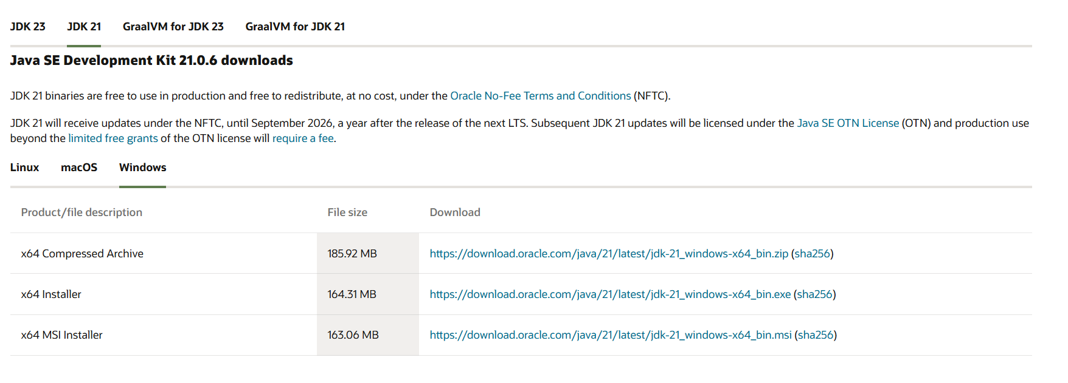

Step4: Choose the appropriate operating system

Step5: Start downloading.

Step6: Once downloaded, navigate to the downloads folder and open the file

Step7: Click Next, accept the terms and conditions, and proceed with the installation

Step8: Java compiler will now be installed successfully.

Step9: After installation, open environment variables by searching for it on your laptop

Step10: In environment variables, navigate to the system variables and select path option.

Step11: Click Edit, create a new path, and enter the required details.

Step12: Copy the path, Click OK, return to System variables, and add a new variable named JAVA_HOME.Paste the copied path and click OK to save.

Step13: To verify the installation, open the command prompt and check the java version using: java –version.



Step14: if the version is displayed, java has been successfully installed

AIM: To print the details of student using Java.

Procedure:

Step1: Open notepad and write the java code.

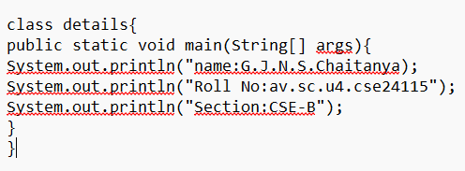

Step2: Save the file in a designated folder.

Step3: Open the command prompt.

Step4: Navigate to the file location and compile the code using: javac FILEname.java

Step5: After successful compilation, a.class file will be generated

Step 6: To see the output type java and file name in command prompt by java FILE name

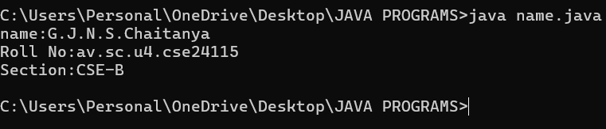

Step 7: The output will be displayed in the Command Prompt.

MY ERROR:

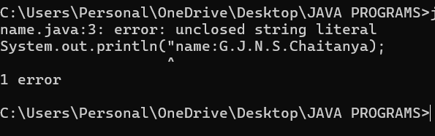

Ensure that after completion the statement close it with single or double quotes.

WEEK-2

1. AIM:

**Simple Java Program for finding simple interest by taking input from**

**User**

**Code:**

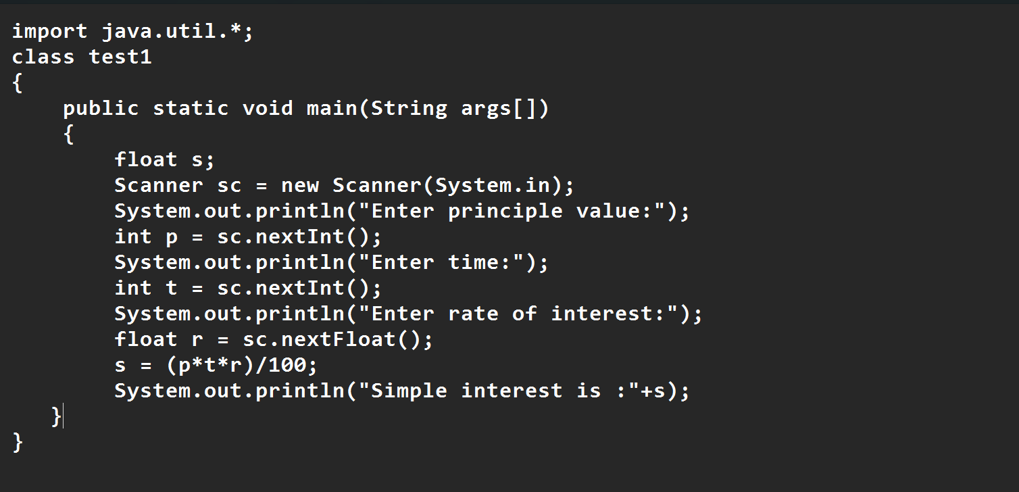

**Output:**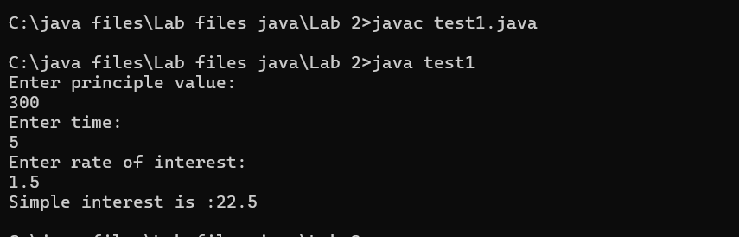

|  |  |  |  |
| --- | --- | --- | --- |
| **S.No** | **Error type** | **Reason for error** | **rectification** |
| **1** | **Runtime error** | **Incorrect path** | **Copied correct path** |
| **2** | **Syntax error** | **{ missing** | **{ added** |
| **3** | **Logical error** | **Wrong formula** | **Formula rectified** |
|  |  |  |  |

**2 )AIM:**

**.Write a simple program to calculate factorial of a number and read the**

**input from user**

**code:**

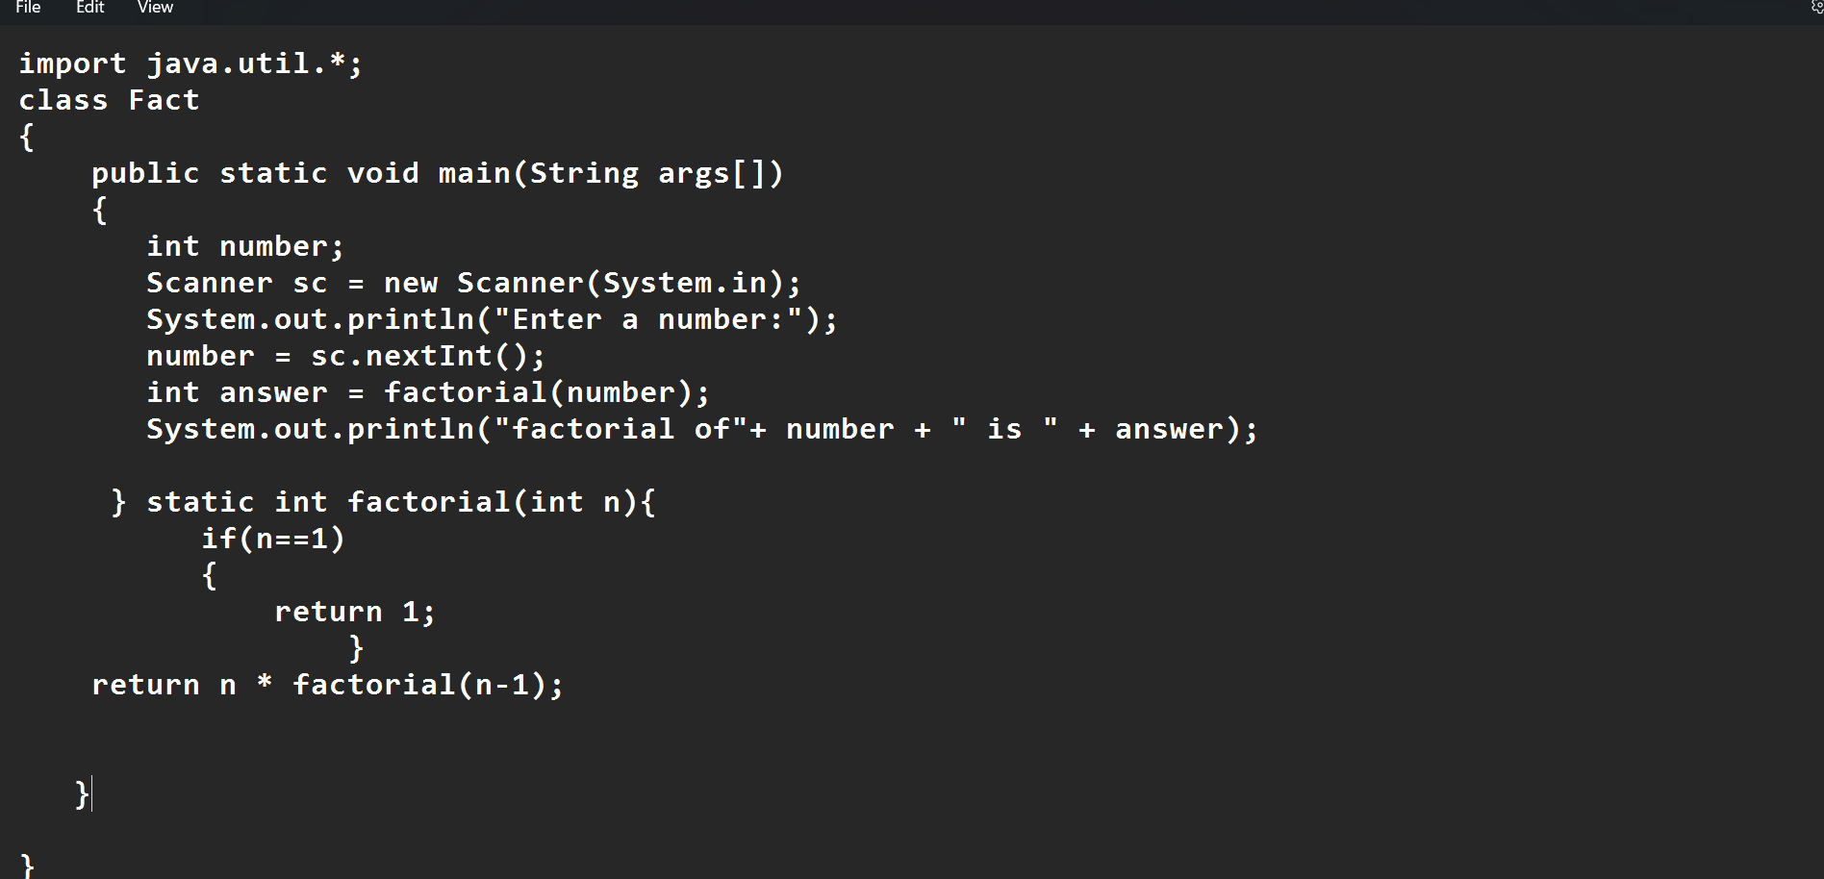

**Output:**

|  |  |  |  |
| --- | --- | --- | --- |
| **S.No** | **Error type** | **Reason for error** | **Rectification** |
| **1** | **Undeclared variable error** | **Missing variable** | **Variable declared** |
| **2** | **Missing import statement** | **Not importing packages** | **Packages imported** |
| **3** | **Logical error** | **Wrong formula** | **Formula rectified** |

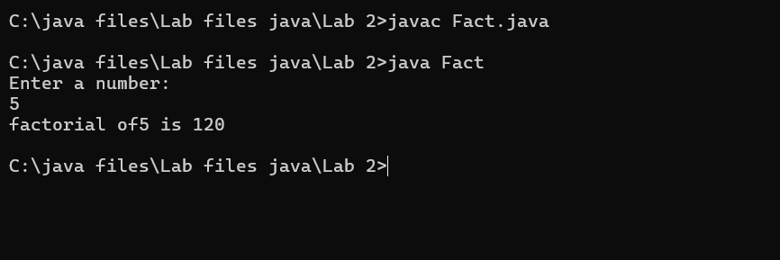

|  |  |  |  |
| --- | --- | --- | --- |
| **S.No** | **Error type** | **Reason for error** | **Rectification** |
| **1** | **Undeclared variable error** | **Missing variable** | **Variable declared** |
| **2** | **Missing import statement** | **Not importing packages** | **Packages imported** |
| **3** | **Logical error** | **Wrong formula** | **Formula rectified** |
|  |  |  |  |
|  |  |  |  |
|  |  |  |  |

**3) AIM:**

**Write a program to to calculate the fibonacii sequence and take the input from user**

**Code:**

**import java.util.*;**

**class fibo**

**{**

**public static void main(String args[])**

**{**

**Scanner sc = new Scanner(System.in);**

**int num;**

**int f3;**

**int f1 = 0;**

**int f2 = 1;**

**int i = 2;**

**System.out.print("Enter a number:");**

**num = sc.nextInt();**

**System.out.println(f1);**

**System.out.println(f2);**

**while(i<num)**

**{**

**f3 = f1+f2;**

**f1 = f2;**

**f2 = f3;**

**System.out.println(f3);**

**i = i+1;**

**}**

**}**

**}**

**Output:**

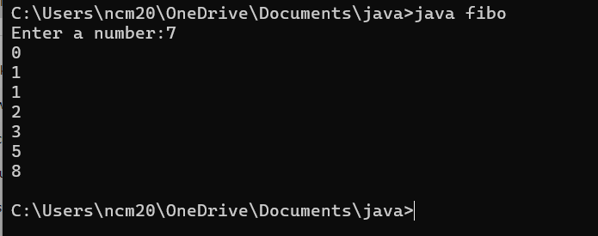

|  |  |  |  |
| --- | --- | --- | --- |
| **S.No** | **Error type** | **Reason for error** | **Rectification** |
| **1** | **Logical error** | **Incorrect formula** | **Formula rectified** |
| **2** | **Run-time error** | **Incorrect path** | **Added correct path** |
| **3** |  |  |  |

**5) AIM**

**Write a java program to convert temperature from Fahrenheit to celsius**

**Code:**

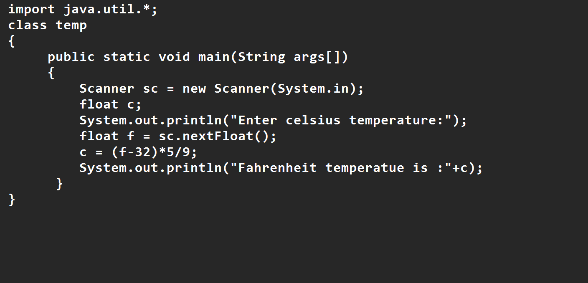

**Output:**

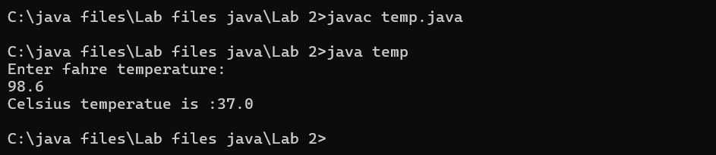

|  |  |  |  |
| --- | --- | --- | --- |
| **S.No** | **Error type** | **Reason for error** | **rectification** |
| **1** | **Syntax error** | **Missing ”** | **“ is added** |
| **2** | **Missing import error** | **Util package missing** | **Util package added** |
| **3** |  |  |  |

**AIM:**

**Write a java program to convert temperature from Celsius to Fahrenheit**

**Code**

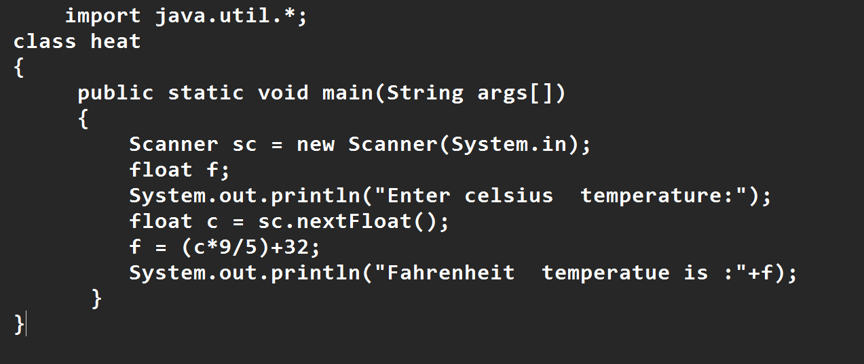

**Output:**

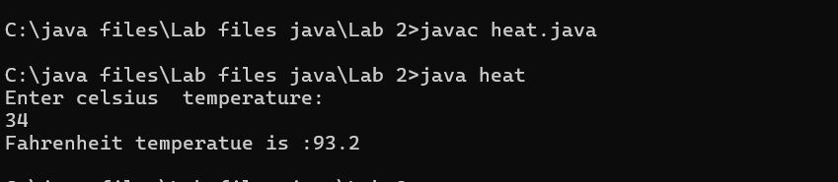

|  |  |  |  |
| --- | --- | --- | --- |
| **S.No** | **Error type** | **Reason for error** | **Rectification** |
| **1** | **Runtime error** | **Incorrect path selection** | **Correct path added** |
| **2** | **Logical error** | **Incorrect logic** | **Correct logic** |
| **3** |  |  |  |

**6) AIM:**

**Write a simple program to find the area of rectangle:**

**Code:**

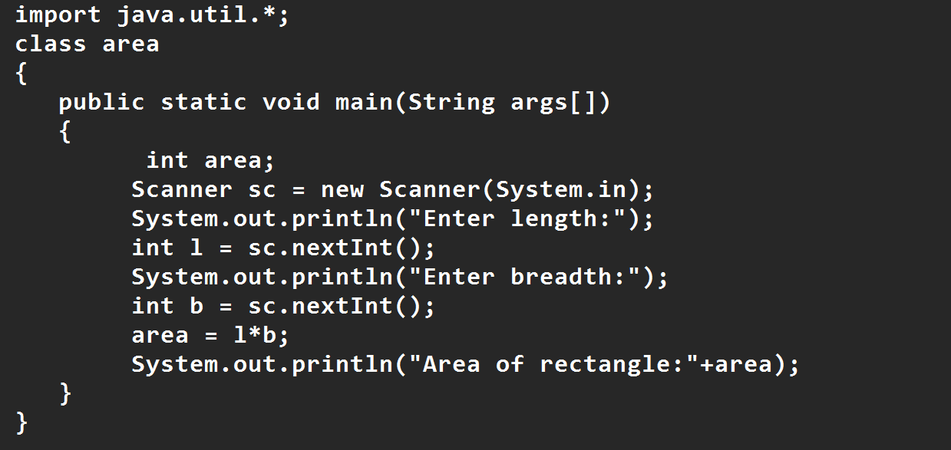

**Output:**

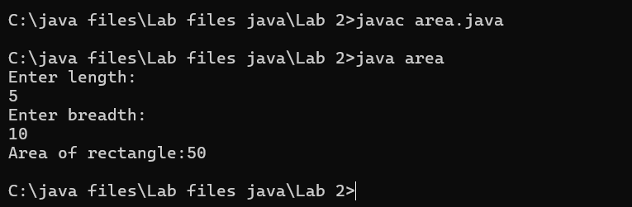

|  |  |  |  |
| --- | --- | --- | --- |
| **S.No** | **Error type** | **Reason for error** | **Rectification** |
| **1** | **Syntax error** | **Semi colon missing** | **Semi colon added** |
| **2** | **Missing import error** | **Import package missing** | **Import package added** |
| **3** |  |  |  |

**7)AIM:**

**Write a program to find the area of triangle by using heron’s formula take the input from the user**

**Code:**

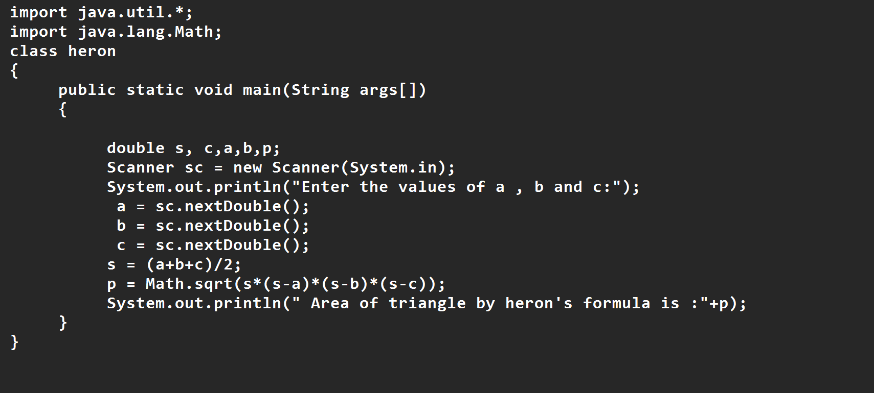

**OUTPUT:**

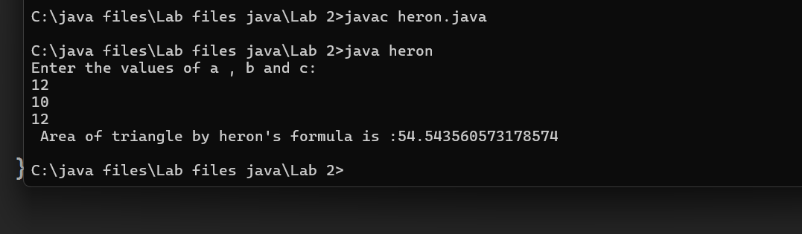

|  |  |  |  |
| --- | --- | --- | --- |
| **S.No** | **Error type** | **Reason for error** | **Rectification** |
| **1** | **Logical error** | **Incorrect formula** | **Formula rectified** |
| **2** | **Name error** | **Undeclared variable** | **Variable declared** |
|  |  |  |  |

**WEEK 3**

**Aim:**

**To create java program with following instructions**

**1.Create a class with name car**

**2. Create four attributes named car_color ,Car_brand,fuel_type,mileage**

**3. Create three methods named start(), stop(). Service()**

**4. Create three objects named car1,car2 and car3**

**import java.util.*;**

**class car**

**{**

**public String Car_color;**

**public String Car_brand;**

**public String fuel_type;**

**public int mileage;**

**public void start()**

**{**

**System.out.println("Car Started:");**

**System.out.println("Car color is :"+Car_color);**

**System.out.println("Car Brand is:"+Car_brand);**

**System.out.println("Car fuel type is:"+fuel_type);**

**System.out.println("Car mileage is:"+mileage);**

**}**

**public void service()**

**{**

**System.out.println("Car Started:");**

**System.out.println("Car color is :"+Car_color);**

**System.out.println("Car Brand is:"+Car_brand);**

**System.out.println("Car fuel type is:"+fuel_type);**

**System.out.println("Car mileage is:"+mileage);**

**}**

**public void stop()**

**{**

**System.out.println("Car Started:");**

**System.out.println("Car color is :"+Car_color);**

**System.out.println("Car Brand is:"+Car_brand);**

**System.out.println("Car fuel type is:"+fuel_type);**

**System.out.println("Car mileage is:"+mileage);**

**}**

**public static void main(String args[])**

**{ System.out.println("\n ncm\n\n");**

**car car1 = new car();**

**car1.Car_color = "Blue";**

**car1.Car_brand = "BMW";**

**car1.fuel_type = "Deisel";**

**car1.mileage = 10;**

**car1.start();**

**car car2 = new car();**

**car2.Car_color = "Red";**

**car2.Car_brand = "Tesla";**

**car2.fuel_type = "EV";**

**car2.mileage = 300;**

**car2.stop();**

**car car3 = new car();**

**car3.Car_color = "Yellow";**

**car3.Car_brand = "MAHINDRA";**

**car3.fuel_type = "Petrol";**

**car3.mileage = 20;**

**car3.service();**

**}**

**}**

**Output:**

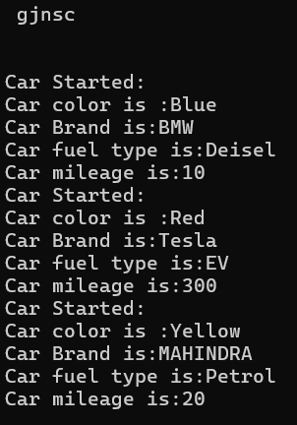

**Class Diagram**

|  |
| --- |
| **Car** |
| **+ car_color: String**  **+ car_brand: String**  **+ fuel_type: String**  **+ mileage: int** |
| **+ Car(): void**  **+ start(): void**  **+ service(): void**  **+ stop(): void** |

**2.AIM:**

**To create a class bankAccount with methods deposit() and withdrawl**

**Code:**

**class BankAccount {**

**private double balance;**

**public BankAccount(double initialBalance) {**

**if (initialBalance > 0) {**

**this.balance = initialBalance;**

**} else {**

**this.balance = 0;**

**}**

**}**

**public void deposit(double amount) {**

**if (amount > 0) {**

**balance = balance + amount;**

**System.out.println("Deposited $ " + amount);**

**} else {**

**System.out.println("Deposited amount must be positive");**

**}**

**}**

**public double getBalance() {**

**return balance;**

**}**

**}**

**public class Main {**

**public static void main(String args[]) {**

**BankAccount account = new BankAccount(1000);**

**account.deposit(500);**

**System.out.println("Current Balance is: $" + account.getBalance());**

**}**

**}**

**Output:**

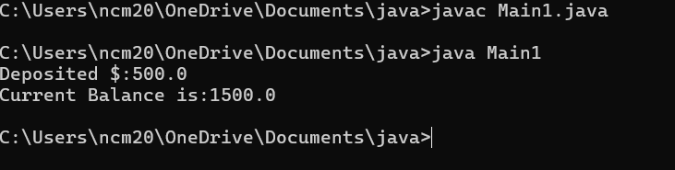

**ERRORS:**

|  |  |  |
| --- | --- | --- |
| **Sno.** | **Error message** | **Error rectification** |
| **1.** | **error: ';' expected**  **cust1.withdraw(3050)** | **Add a “;”**    **cust1.withdraw(3050);** |
| **2.** | **error: cannot find**  **symbol**  **thisCurrBal=CurrBal;** | **Add a “.”**    **this.CurrBal=CurrBal;** |